Computing in medical area

The applications of computing have made so many contributions to society so far. Computing means that people use computer to communicate information, process and manage. We can see the enormous change done by applications of computing especially in medical area.

The most important one is the information can be shared online. For some developing country, they might not have enough facilities or doctors, the information online might save their life. Also for some older, they might not have essential information about some cancer which will cause them miss the optional treatment time. The earlier they diagnose their cancer, the easier for doctors to treat them.

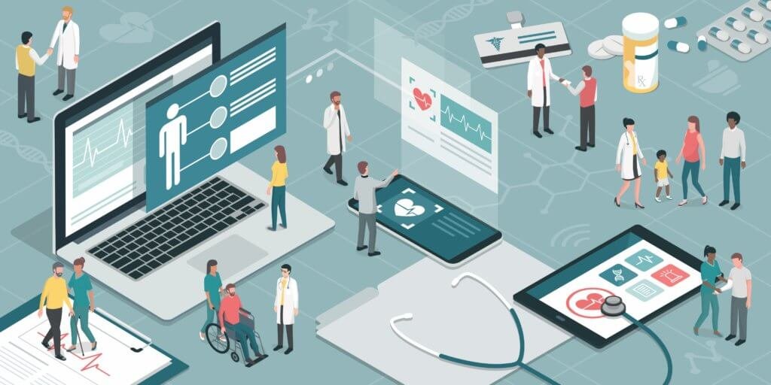

Meanwhile, if you had tried to recognize the machines that is used in hospital, you will realize the computing is used everywhere. From booking an appointment online to the Magnetic Resonance Imaging which is a medical imaging technique used in radiology to form pictures of the anatomy and the physiological processes of the body. During an MRI scan, people lie on a flat bed that's moved into the scanner. Depending on the part of your body being scanned, you'll be moved into the scanner either head first or feet first. The MRI scanner is operated by a radiographer, who is trained in carrying out imaging investigations. They control the scanner using a computer, which is in a different room, to keep it away from the magnetic field generated by the scanner.

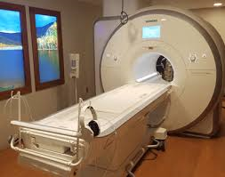

In conclusion, applications of computing offer increasing support to physicians in their daily activity and an increasing potential for future use. The computer may well become or actually it already become an essential medical tool.